MTSE 3000: Fundamentals of Materials Science and Engineering-I
3 Credits; Office Hours by walk in or by appointment
Prof. Srinivasan G. Srivilliputhur, NTDP C136C; (srinivasan.srivilliputhur@unt.edu)

Text book, title, author, and year
Fundamentals of Materials Science and Engineering, An Integrated Approach, by: William D. Callister & David G. Rethwisch, 3rd, 4th, or 5th Edition, John Wiley are acceptable.
Supplemental materials: Electronic copies of lectures on Blackboard.

Specific Course Information
- Brief description of the content of the course (catalog description)
Principles of bonding, structure, and structure/property relationships for metals and their alloys, ceramics, polymers and composites. Emphasis on properties and how processes change structure and, consequently, properties.
- Prerequisites or co-requisites
PHYS 1710. CHEM 1410/CHEM 1430 or CHEM 1415/CHEM 1435.
- Indicate whether a required, elective, or selected elective course: Required

Brief list of topics to be covered
I. Electronic and Atomic Structure and Bonding
- Atomic structure
- Bonding types and correlations with properties
II. Material Building Blocks
- Crystal structures (Metals and Ceramics)
- Miller indices
- Single, polycrystalline, and non-crystalline materials
- Polymeric structures
- Defects
III. On Microstructure-Property Relationships
- Mechanical properties
- Deformation and strengthening mechanisms
IV. On Microstructural Evolution
- Phase diagrams
- Diffusion
- Phase transformations
V. Materials in Application
- Failure and corrosion
- Material applications and processing
- Team presentations on material applications

Specific goals for the course
- Specific outcomes of instruction
- Explicitly indicate which of the student outcomes listed in Criterion 3 or any other outcomes are addressed by the course.

Student/ABET Outcome | 1 | 2 | 3 | 4 | 5 | 6 | 7
Specific Course Learning Outcome
- Demonstrate ability to relate bond energy to properties of engineering materials | X |  |  |  |  | X
- Interpret various crystal structures using Miller Indices for planes and directions | X |  |  |  |  | X
- Determine contributions of various strengthening mechanisms, including solid solution strengthening, precipitation strengthening, strain hardening, and grain size strengthening (the Hall-Petch relationship) | X
- Demonstrate ability to read a phase diagram, including determining phase diagram type, predict phase compositions (given C₀ and T), and predict microstructures for given compositions. | X |  |  |  |  | X
- Interpret mechanical properties, including yield strength, ultimate tensile strength, and elastic modulus from engineering plots of σ-ε | X |  |  |  |  | X
- Exhibit awareness of societal implications associated with various materials, including specifically occupational safety and health and global availabilities of commodity material |  |  |  | X |  |  | X
- Conduct and present a material selection survey as part of a team for current materials applications. | X | X | X |  | X |  | X

Important Class Policies
Miscellaneous Points
- Canvas will be used as the primary communication tool and for posting lecture slides, homework assignments and solutions, and exam topics.
- Effort will be made to grade your assignments and exams within two weeks after they are due. Late assignments (homework or project) will NOT be accepted.
- Each quiz will be limited to one or two questions with a time limit of 15 minutes. The content will be based on recent homework and example questions explained in your class.
- There will be a total of three exams, each of which may contain multiple choice, short answer, and quantitative questions/problems.
- You are allowed to use only a calculator, pencils, pens, and eraser in your quizzes and exams. Earphones, cell phones, laptops, smart watches, and other devices are banned.
Prerequisites PHYS 1710, CHEM 1410/CHEM 1430 or CHEM 1415/CHEM 1435.
Tentative Grading Scheme with weight percent contributions to your grade (subject to change)
Homework Average 10%
Quiz Average 10%
Exam Average 60%
Team Project 20%
Team Project
The project consists of a final report (7.5% of the course grade) and a presentation (7.5% of the course grade). Each student will rate the level and quality of their team members’ contribution to the project in their final examination (5% of the course grade).
Makeup Exam Policy: Makeup exams will be allowed only for mitigating circumstances such as business travel, serious illness of student or a close family member. A student missing her/his exam due such unavoidable situations must notify the instructor in writing and provide necessary documentation such as doctor’s note, conference talk abstract, etc.
Class Attendance is Mandatory. Optimal learning demands regular class attendance and active listening/participation in classroom discussion. Please notify the instructor if you have to miss a class or will be late. 10 or more unexcused absences will lead to a student being dropped from the class. Excused absences include illness, conference travel, family emergency, religious holiday, and any other unplanned difficulty as determined by the instructor. Five unexcused absences will result in a 5-point deduction from your final course grade. Each additional unexcused absence will result in an additional point deduction in your final course grade (up to 9 absences). While traffic and other issues present difficulties getting to Discovery Park before class, being more than 15 minutes late for class is disruptive and will be considered “being late.” Consequently, six unexcused late arrivals will result in a 0.5-point deduction from your final course grade. Each additional late arrival will result in an additional 0.5-point deduction in your final course grade.
Calculators You may use a scientific calculator in your exams and quizzes. Programmable calculators and sharing of calculators are not allowed.
Your calculator must be able to find the value of trigonometric (SIN, COS, TAN), exponential (e^{x}), power (x^{y}), square root, natural log (LN), base 10 log (LOG), and inverse functions
Cell Phone Usage Policy Cell phones and other electronic communication devices cannot be used, and must remain “out-of-sight”, during class time. Texting, online activity, electronic messaging, playing games etc. during class time are also prohibited. Students violating this policy will be asked to leave the class.
Disabilities Accommodation
UNT complies with Section 504 of the 1973 Rehabilitation Act and with the Americans with Disabilities Act of 1990. It provides reasonable accommodation and auxiliary aids to individuals with disabilities, as defined under the law. If you believe you have a disability requiring accommodation, please contact the Office of Disability Accommodation at 940-565-4323 during the first week of class.
Authorized Absences and Extenuating Circumstances
Absences for participating in university-sponsored activities must be verified by the Dean of Students. Consideration of such absences will be made for quizzes and examinations, but not homework. For participation in sponsored activities, a student must seek approval prior to their absence. For absences due to extenuating circumstances, you have 1 week to contact the instructor to begin the process.
Absence for Religious Holidays
In accordance with state law, a student absent due to the observance of a religious holiday may take examinations or complete assignments scheduled for the day(s) missed, including those missed for travel, within a reasonable time after the absence. The student is responsible to notify the instructor of each class of the date of the anticipated absence as early in the semester as possible. Only holidays or holy days observed by a religion whose place of worship is exempt from property taxation under Section 11.20 of the Tax Code may be included. A student who is excused under this provision may not be penalized for the absence.
Statement of Expectations for Student Conduct and Academic Integrity
Consult UNT’s academic manual for the relevant policies and procedures. The students must conduct themselves in a professional manner, and be honest and ethical in their academic work. Academic dishonesty such as plagiarism and cheating will NOT be tolerated. Academic dishonesty is defined as an intentional act of deception in one or more of the following areas:
- Assisting – helping another commit an act of academic dishonesty
- Cheating – use or attempted use of unauthorized materials, information or study aids
- Fabrication – falsification or invention of any information
- Plagiarism – representing the words or ideas of another person as one's own.
- Tampering – altering or interfering with evaluation instruments and documents
Any student in violation of these policies will be given an overall F grade (Fail). In addition, each violation will be forwarded to university administrators for additional punishments/sanctions in accordance with university policies. When in doubt, please ask me.
Brief list of topics to be covered

I. Electronic and Atomic Structure and Bonding
- Atomic structure
- Bonding types and correlations with properties
II. Material Building Blocks
- Crystal structures (Metals and Ceramics)
- Miller indices
- Single, polycrystalline, and non-crystalline materials
- Polymeric structures
- Defects
III. On Microstructure-Property Relationships
- Mechanical properties
- Deformation and strengthening mechanisms
IV. On Microstructural Evolution
- Phase diagrams
- Diffusion
- Phase transformations
V. Materials in Application
- Failure and corrosion
- Material applications and processing
- Team presentations on material applications

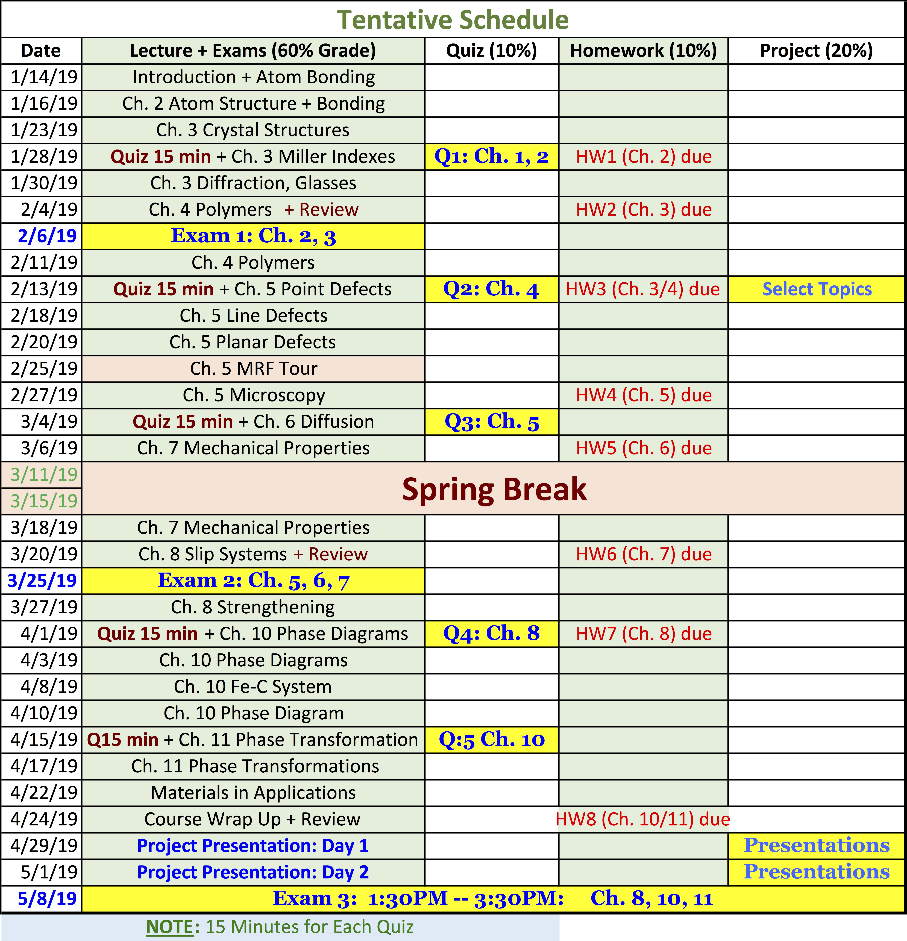

Suggested Project Topics
Materials (metals, alloys, polymers, and ceramics) for following applications are acceptable topics. Your report must include one specific material used for that application, the reason for choosing that material, its composition, how it is made, its salient property for the application, and the microstructure.
- Car bodies
- Buildings
- Jet engines
- Engine pistons and cylinder heads
- Furnace heating elements
- Heat exchangers in chemical industry reactors
- Water pipelines
- Gas pipelines
- Rocket nose cones
- Aircraft frames
- Bone implants
- Heart valves.
- Bicycle frames
- Football helmets
- Golf club
- Tennis racquet
- Baseball bat
- Basket ball
- Heat exchanger materials for microelectronic devices.

Each team’s project report and presentation must address the following: (i) Identify and explain current materials need, (ii) Select a material and justify your selection; (iii) Discuss atomic bonding and structure of selected material; (iv) Discuss phase diagram of the selected material; (v) Predict microstructure, strengthening mechanisms, and mechanical properties; and (vi) Estimate impact on society.
Project Teams: Please self-organize into teams with three members each and email the instructor on or before January 28, 2019.
Project Topic Selection: Each project team must email their project topic to the instructor on or before February 13, 2019.

Project Report: Your report should not exceed 10 pages (single spaced, 12 point Symbol and/or Times New Roman fonts, and 1-inch margins around). Legends and labels in the embedded figures should be font size 12 and be clearly legible. Use only metric/SI units. Abstract, literature review, figures, tables, and references are not counted for the 10-page limit.

