Gypsy Language and Culture

LING 4120, Fall 2015

Instructor: Dr. Sadaf Munshi (Email: sadafmunshi@unt.edu)
Class meets: M/W 2.00-3.20pm in WH 212
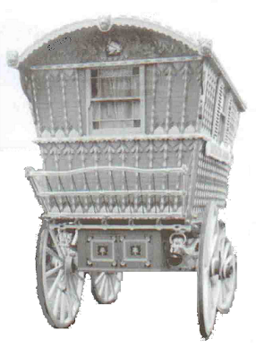
DESCREPTION
The Roma, more popularly known as “GYPSIES”, and often associated with stereotypical images such as fortune-telling, black-magic, theft and robbery, have been treated as the lowest and most stigmatized part of the social stratum in the west. The aim of this course is to present the historical, linguistic, and cultural origins of Roma. Based on the social and linguistic evidence, we will discuss various theories relating to Roma exodus out of India and their migration into Europe. We will also examine the five and a half centuries of slavery, the Gypsy Holocaust, their transportation to the Americas, and their current struggle for civil and political rights. Main topics to be dealt with in the course are: the socio-cultural construction of the “Gypsy” image, the Indian roots of their language and culture, the historical development of the Romani language, and the interaction of Roma with the non-Gypsy or “gadže” world.
TEXTBOOKS
Required
Ian Hancock (2003): We Are the Romani People. Hatfield: University of Hertfordshire Press

Recommended/Optional
Ian Hancock (1995): A handbook of Vlax Romani. Slavica Publishers, Inc.

REQUIREMENTS
Two in-class tests (50% of the grade) and two short papers (50% of the total grade) 5-7 pages

Attendance and Participation:
Your attendance and participation in class is very important. Regular and consistent attendance is required to earn full credit for the course. DO NOT miss a class unless you have a genuine excuse to do so. Unexcused absences will be penalized. If you have 3-7 unexcused absences, your grade will be lowered by one letter grade. If you have 8 or more unexcused absences, you will receive an F. I generally notice students who come to class and nap, read rather than listen to the lecture, surf the web on their laptop, and so forth. Your grades will be affected by your attendance and how you conduct yourself when you attend. Students who have few absences, come to class prepared, and contribute regularly to discussion and in-class problem solving will be awarded full credit. Please switch off your cell phone or other electronic devices before class starts.

